**Beneath the Waves: Unraveling Coral Mysteries through Deep Learning**

**Introduction:**

"Beneath the Waves: Unraveling Coral Mysteries through Deep Learning" embarks on a groundbreaking journey to explore and understand the enigmatic lives of these underwater wonders, with a particular focus on the divergent tales told by the healthy and bleached corals.

Identification of coral image will be a tough problem with human eyes who don't have much knowledge, but this process can be time-consuming and subjective. With the advancements in computer vision and deep learning techniques, it is now possible to automatically classify the corals which are healthy and bleached using deep learning techniques.

The use of deep learning in Coral image classification has several important applications. For example, it can be used to improve our understanding of physical attributes.

**Technical Architecture:**

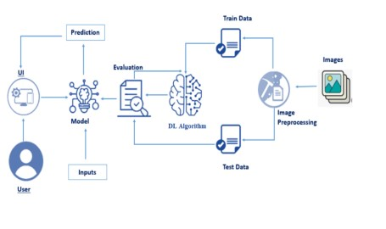

[www.smartbridge.com](http://www.smartbridge.com)

**PreRequisites:**

To complete this project, you must require the following software’s, concepts, and packages

Anaconda Navigator is a free and open-source distribution of the Python and R programming languages for data science and machine learning related applications. It can be installed on Windows, Linux, and macOS.Conda is an open-source, cross-platform, package management system. Anaconda comes with so very nice tools like JupyterLab, Jupyter Notebook, QtConsole, VScode, Glueviz, Orange, Rstudio, Visual Studio Code. For this project, we will be using Jupyter notebook and VS code.

● Deep Learning Concepts o VGG16 is a type of CNN (Convolutional Neural Network) that is considered to be one of the best computer vision models to date. [The](https://www.bing.com/ck/a?!&&p=2534a29f143b523cJmltdHM9MTY5MDMwMjgxNA&ptn=3&hsh=3&fclid=ffaca58c-2b08-11ee-8959-ec2bd1d40556&u=a1aHR0cHM6Ly9tZWRpdW0uY29tL0BteWdyZWF0bGVhcm5pbmcvZXZlcnl0aGluZy15b3UtbmVlZC10by1rbm93LWFib3V0LXZnZzE2LTczMTVkZWZiNTkxOA&ntb=1&bc=1) [creators](https://www.bing.com/ck/a?!&&p=2534a29f143b523cJmltdHM9MTY5MDMwMjgxNA&ptn=3&hsh=3&fclid=ffaca58c-2b08-11ee-8959-ec2bd1d40556&u=a1aHR0cHM6Ly9tZWRpdW0uY29tL0BteWdyZWF0bGVhcm5pbmcvZXZlcnl0aGluZy15b3UtbmVlZC10by1rbm93LWFib3V0LXZnZzE2LTczMTVkZWZiNTkxOA&ntb=1&bc=1) [of](https://www.bing.com/ck/a?!&&p=2534a29f143b523cJmltdHM9MTY5MDMwMjgxNA&ptn=3&hsh=3&fclid=ffaca58c-2b08-11ee-8959-ec2bd1d40556&u=a1aHR0cHM6Ly9tZWRpdW0uY29tL0BteWdyZWF0bGVhcm5pbmcvZXZlcnl0aGluZy15b3UtbmVlZC10by1rbm93LWFib3V0LXZnZzE2LTczMTVkZWZiNTkxOA&ntb=1&bc=1) [this](https://www.bing.com/ck/a?!&&p=2534a29f143b523cJmltdHM9MTY5MDMwMjgxNA&ptn=3&hsh=3&fclid=ffaca58c-2b08-11ee-8959-ec2bd1d40556&u=a1aHR0cHM6Ly9tZWRpdW0uY29tL0BteWdyZWF0bGVhcm5pbmcvZXZlcnl0aGluZy15b3UtbmVlZC10by1rbm93LWFib3V0LXZnZzE2LTczMTVkZWZiNTkxOA&ntb=1&bc=1) [model](https://www.bing.com/ck/a?!&&p=2534a29f143b523cJmltdHM9MTY5MDMwMjgxNA&ptn=3&hsh=3&fclid=ffaca58c-2b08-11ee-8959-ec2bd1d40556&u=a1aHR0cHM6Ly9tZWRpdW0uY29tL0BteWdyZWF0bGVhcm5pbmcvZXZlcnl0aGluZy15b3UtbmVlZC10by1rbm93LWFib3V0LXZnZzE2LTczMTVkZWZiNTkxOA&ntb=1&bc=1) [evaluated](https://www.bing.com/ck/a?!&&p=2534a29f143b523cJmltdHM9MTY5MDMwMjgxNA&ptn=3&hsh=3&fclid=ffaca58c-2b08-11ee-8959-ec2bd1d40556&u=a1aHR0cHM6Ly9tZWRpdW0uY29tL0BteWdyZWF0bGVhcm5pbmcvZXZlcnl0aGluZy15b3UtbmVlZC10by1rbm93LWFib3V0LXZnZzE2LTczMTVkZWZiNTkxOA&ntb=1&bc=1) [the](https://www.bing.com/ck/a?!&&p=2534a29f143b523cJmltdHM9MTY5MDMwMjgxNA&ptn=3&hsh=3&fclid=ffaca58c-2b08-11ee-8959-ec2bd1d40556&u=a1aHR0cHM6Ly9tZWRpdW0uY29tL0BteWdyZWF0bGVhcm5pbmcvZXZlcnl0aGluZy15b3UtbmVlZC10by1rbm93LWFib3V0LXZnZzE2LTczMTVkZWZiNTkxOA&ntb=1&bc=1) [networks and](https://www.bing.com/ck/a?!&&p=2534a29f143b523cJmltdHM9MTY5MDMwMjgxNA&ptn=3&hsh=3&fclid=ffaca58c-2b08-11ee-8959-ec2bd1d40556&u=a1aHR0cHM6Ly9tZWRpdW0uY29tL0BteWdyZWF0bGVhcm5pbmcvZXZlcnl0aGluZy15b3UtbmVlZC10by1rbm93LWFib3V0LXZnZzE2LTczMTVkZWZiNTkxOA&ntb=1&bc=1) [increased](https://www.bing.com/ck/a?!&&p=2534a29f143b523cJmltdHM9MTY5MDMwMjgxNA&ptn=3&hsh=3&fclid=ffaca58c-2b08-11ee-8959-ec2bd1d40556&u=a1aHR0cHM6Ly9tZWRpdW0uY29tL0BteWdyZWF0bGVhcm5pbmcvZXZlcnl0aGluZy15b3UtbmVlZC10by1rbm93LWFib3V0LXZnZzE2LTczMTVkZWZiNTkxOA&ntb=1&bc=1) [the](https://www.bing.com/ck/a?!&&p=2534a29f143b523cJmltdHM9MTY5MDMwMjgxNA&ptn=3&hsh=3&fclid=ffaca58c-2b08-11ee-8959-ec2bd1d40556&u=a1aHR0cHM6Ly9tZWRpdW0uY29tL0BteWdyZWF0bGVhcm5pbmcvZXZlcnl0aGluZy15b3UtbmVlZC10by1rbm93LWFib3V0LXZnZzE2LTczMTVkZWZiNTkxOA&ntb=1&bc=1) [depth](https://www.bing.com/ck/a?!&&p=2534a29f143b523cJmltdHM9MTY5MDMwMjgxNA&ptn=3&hsh=3&fclid=ffaca58c-2b08-11ee-8959-ec2bd1d40556&u=a1aHR0cHM6Ly9tZWRpdW0uY29tL0BteWdyZWF0bGVhcm5pbmcvZXZlcnl0aGluZy15b3UtbmVlZC10by1rbm93LWFib3V0LXZnZzE2LTczMTVkZWZiNTkxOA&ntb=1&bc=1) [using](https://www.bing.com/ck/a?!&&p=2534a29f143b523cJmltdHM9MTY5MDMwMjgxNA&ptn=3&hsh=3&fclid=ffaca58c-2b08-11ee-8959-ec2bd1d40556&u=a1aHR0cHM6Ly9tZWRpdW0uY29tL0BteWdyZWF0bGVhcm5pbmcvZXZlcnl0aGluZy15b3UtbmVlZC10by1rbm93LWFib3V0LXZnZzE2LTczMTVkZWZiNTkxOA&ntb=1&bc=1) [an](https://www.bing.com/ck/a?!&&p=2534a29f143b523cJmltdHM9MTY5MDMwMjgxNA&ptn=3&hsh=3&fclid=ffaca58c-2b08-11ee-8959-ec2bd1d40556&u=a1aHR0cHM6Ly9tZWRpdW0uY29tL0BteWdyZWF0bGVhcm5pbmcvZXZlcnl0aGluZy15b3UtbmVlZC10by1rbm93LWFib3V0LXZnZzE2LTczMTVkZWZiNTkxOA&ntb=1&bc=1) [architecture](https://www.bing.com/ck/a?!&&p=2534a29f143b523cJmltdHM9MTY5MDMwMjgxNA&ptn=3&hsh=3&fclid=ffaca58c-2b08-11ee-8959-ec2bd1d40556&u=a1aHR0cHM6Ly9tZWRpdW0uY29tL0BteWdyZWF0bGVhcm5pbmcvZXZlcnl0aGluZy15b3UtbmVlZC10by1rbm93LWFib3V0LXZnZzE2LTczMTVkZWZiNTkxOA&ntb=1&bc=1) [with](https://www.bing.com/ck/a?!&&p=2534a29f143b523cJmltdHM9MTY5MDMwMjgxNA&ptn=3&hsh=3&fclid=ffaca58c-2b08-11ee-8959-ec2bd1d40556&u=a1aHR0cHM6Ly9tZWRpdW0uY29tL0BteWdyZWF0bGVhcm5pbmcvZXZlcnl0aGluZy15b3UtbmVlZC10by1rbm93LWFib3V0LXZnZzE2LTczMTVkZWZiNTkxOA&ntb=1&bc=1) [very](https://www.bing.com/ck/a?!&&p=2534a29f143b523cJmltdHM9MTY5MDMwMjgxNA&ptn=3&hsh=3&fclid=ffaca58c-2b08-11ee-8959-ec2bd1d40556&u=a1aHR0cHM6Ly9tZWRpdW0uY29tL0BteWdyZWF0bGVhcm5pbmcvZXZlcnl0aGluZy15b3UtbmVlZC10by1rbm93LWFib3V0LXZnZzE2LTczMTVkZWZiNTkxOA&ntb=1&bc=1) [small](https://www.bing.com/ck/a?!&&p=2534a29f143b523cJmltdHM9MTY5MDMwMjgxNA&ptn=3&hsh=3&fclid=ffaca58c-2b08-11ee-8959-ec2bd1d40556&u=a1aHR0cHM6Ly9tZWRpdW0uY29tL0BteWdyZWF0bGVhcm5pbmcvZXZlcnl0aGluZy15b3UtbmVlZC10by1rbm93LWFib3V0LXZnZzE2LTczMTVkZWZiNTkxOA&ntb=1&bc=1) [(3](https://www.bing.com/ck/a?!&&p=2534a29f143b523cJmltdHM9MTY5MDMwMjgxNA&ptn=3&hsh=3&fclid=ffaca58c-2b08-11ee-8959-ec2bd1d40556&u=a1aHR0cHM6Ly9tZWRpdW0uY29tL0BteWdyZWF0bGVhcm5pbmcvZXZlcnl0aGluZy15b3UtbmVlZC10by1rbm93LWFib3V0LXZnZzE2LTczMTVkZWZiNTkxOA&ntb=1&bc=1) [×](https://www.bing.com/ck/a?!&&p=2534a29f143b523cJmltdHM9MTY5MDMwMjgxNA&ptn=3&hsh=3&fclid=ffaca58c-2b08-11ee-8959-ec2bd1d40556&u=a1aHR0cHM6Ly9tZWRpdW0uY29tL0BteWdyZWF0bGVhcm5pbmcvZXZlcnl0aGluZy15b3UtbmVlZC10by1rbm93LWFib3V0LXZnZzE2LTczMTVkZWZiNTkxOA&ntb=1&bc=1) [3)](https://www.bing.com/ck/a?!&&p=2534a29f143b523cJmltdHM9MTY5MDMwMjgxNA&ptn=3&hsh=3&fclid=ffaca58c-2b08-11ee-8959-ec2bd1d40556&u=a1aHR0cHM6Ly9tZWRpdW0uY29tL0BteWdyZWF0bGVhcm5pbmcvZXZlcnl0aGluZy15b3UtbmVlZC10by1rbm93LWFib3V0LXZnZzE2LTczMTVkZWZiNTkxOA&ntb=1&bc=1) [convolution](https://www.bing.com/ck/a?!&&p=2534a29f143b523cJmltdHM9MTY5MDMwMjgxNA&ptn=3&hsh=3&fclid=ffaca58c-2b08-11ee-8959-ec2bd1d40556&u=a1aHR0cHM6Ly9tZWRpdW0uY29tL0BteWdyZWF0bGVhcm5pbmcvZXZlcnl0aGluZy15b3UtbmVlZC10by1rbm93LWFib3V0LXZnZzE2LTczMTVkZWZiNTkxOA&ntb=1&bc=1) [filters, which](https://www.bing.com/ck/a?!&&p=2534a29f143b523cJmltdHM9MTY5MDMwMjgxNA&ptn=3&hsh=3&fclid=ffaca58c-2b08-11ee-8959-ec2bd1d40556&u=a1aHR0cHM6Ly9tZWRpdW0uY29tL0BteWdyZWF0bGVhcm5pbmcvZXZlcnl0aGluZy15b3UtbmVlZC10by1rbm93LWFib3V0LXZnZzE2LTczMTVkZWZiNTkxOA&ntb=1&bc=1) [showed](https://www.bing.com/ck/a?!&&p=2534a29f143b523cJmltdHM9MTY5MDMwMjgxNA&ptn=3&hsh=3&fclid=ffaca58c-2b08-11ee-8959-ec2bd1d40556&u=a1aHR0cHM6Ly9tZWRpdW0uY29tL0BteWdyZWF0bGVhcm5pbmcvZXZlcnl0aGluZy15b3UtbmVlZC10by1rbm93LWFib3V0LXZnZzE2LTczMTVkZWZiNTkxOA&ntb=1&bc=1) [a](https://www.bing.com/ck/a?!&&p=2534a29f143b523cJmltdHM9MTY5MDMwMjgxNA&ptn=3&hsh=3&fclid=ffaca58c-2b08-11ee-8959-ec2bd1d40556&u=a1aHR0cHM6Ly9tZWRpdW0uY29tL0BteWdyZWF0bGVhcm5pbmcvZXZlcnl0aGluZy15b3UtbmVlZC10by1rbm93LWFib3V0LXZnZzE2LTczMTVkZWZiNTkxOA&ntb=1&bc=1) [significant](https://www.bing.com/ck/a?!&&p=2534a29f143b523cJmltdHM9MTY5MDMwMjgxNA&ptn=3&hsh=3&fclid=ffaca58c-2b08-11ee-8959-ec2bd1d40556&u=a1aHR0cHM6Ly9tZWRpdW0uY29tL0BteWdyZWF0bGVhcm5pbmcvZXZlcnl0aGluZy15b3UtbmVlZC10by1rbm93LWFib3V0LXZnZzE2LTczMTVkZWZiNTkxOA&ntb=1&bc=1) [improvement](https://www.bing.com/ck/a?!&&p=2534a29f143b523cJmltdHM9MTY5MDMwMjgxNA&ptn=3&hsh=3&fclid=ffaca58c-2b08-11ee-8959-ec2bd1d40556&u=a1aHR0cHM6Ly9tZWRpdW0uY29tL0BteWdyZWF0bGVhcm5pbmcvZXZlcnl0aGluZy15b3UtbmVlZC10by1rbm93LWFib3V0LXZnZzE2LTczMTVkZWZiNTkxOA&ntb=1&bc=1) [on](https://www.bing.com/ck/a?!&&p=2534a29f143b523cJmltdHM9MTY5MDMwMjgxNA&ptn=3&hsh=3&fclid=ffaca58c-2b08-11ee-8959-ec2bd1d40556&u=a1aHR0cHM6Ly9tZWRpdW0uY29tL0BteWdyZWF0bGVhcm5pbmcvZXZlcnl0aGluZy15b3UtbmVlZC10by1rbm93LWFib3V0LXZnZzE2LTczMTVkZWZiNTkxOA&ntb=1&bc=1) [the](https://www.bing.com/ck/a?!&&p=2534a29f143b523cJmltdHM9MTY5MDMwMjgxNA&ptn=3&hsh=3&fclid=ffaca58c-2b08-11ee-8959-ec2bd1d40556&u=a1aHR0cHM6Ly9tZWRpdW0uY29tL0BteWdyZWF0bGVhcm5pbmcvZXZlcnl0aGluZy15b3UtbmVlZC10by1rbm93LWFib3V0LXZnZzE2LTczMTVkZWZiNTkxOA&ntb=1&bc=1) [prior-art](https://www.bing.com/ck/a?!&&p=2534a29f143b523cJmltdHM9MTY5MDMwMjgxNA&ptn=3&hsh=3&fclid=ffaca58c-2b08-11ee-8959-ec2bd1d40556&u=a1aHR0cHM6Ly9tZWRpdW0uY29tL0BteWdyZWF0bGVhcm5pbmcvZXZlcnl0aGluZy15b3UtbmVlZC10by1rbm93LWFib3V0LXZnZzE2LTczMTVkZWZiNTkxOA&ntb=1&bc=1) [configurations](https://www.bing.com/ck/a?!&&p=2534a29f143b523cJmltdHM9MTY5MDMwMjgxNA&ptn=3&hsh=3&fclid=ffaca58c-2b08-11ee-8959-ec2bd1d40556&u=a1aHR0cHM6Ly9tZWRpdW0uY29tL0BteWdyZWF0bGVhcm5pbmcvZXZlcnl0aGluZy15b3UtbmVlZC10by1rbm93LWFib3V0LXZnZzE2LTczMTVkZWZiNTkxOA&ntb=1&bc=1) . It is a convolution neural network (CNN) model supporting 19 layers.

* Flask: Flask is a popular Python web framework, meaning it is a third-party Python library used for developing web applications.

**● Deep Learning Concepts**

* **CNN:** <https://towardsdatascience.com/basics-of-the-classic-cnn-a3dce1225add>
* **VGG16:**<https://medium.com/@mygreatlearning/what-is-vgg16-introduction-to-vgg16-f2d63849f615>
* **ResNet-50:**<https://towardsdatascience.com/understanding-and-coding-a-resnet-in-keras-446d7ff84d33>
* **Inception-V3:** <https://iq.opengenus.org/inception-v3-model-architecture/>
* **Xception:** <https://pyimagesearch.com/2017/03/20/imagenet-vggnet-resnet-inception-xception-keras/>

www.smartbridge.com

**Project Objectives:**

By the end of this project you will:

* Know fundamental concepts and techniques of Convolutional Neural Network.
* Gain a broad understanding of image data.
* Know how to pre-process/clean the data using different data preprocessing techniques.
* Know how to build a web application using the Flask framework.

**Project Flow:**

* The user interacts with the UI (User Interface) to choose the image.
* The chosen image analyzed by the model which is integrated with flask application.
* The Xception Model analyzes the image, then the prediction is showcased on the Flask UI.

To accomplish this, we have to complete all the activities and tasks listed below

o Data Collection.

* + Create a Train and Test path.
  + Data Pre-processing.
  + Import the required library
  + Configure ImageDataGenerator class
  + ApplyImageDataGenerator functionality to Trainset and Testset
  + Model Building
  + Pre-trained CNN model as a Feature Extractor
  + Adding Dense Layer
  + Configure the Learning Process
  + Train the model
  + Save the Model
  + Test the model
  + Application Building
  + Create an HTML file
  + Build Python Code

www.smartbridge.com

**Project Structure:**

Create a Project folder which contains files as shown below

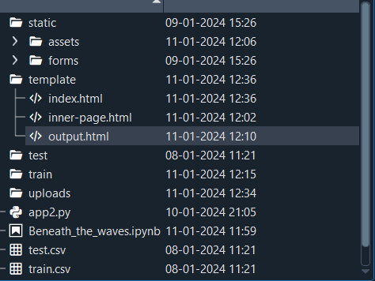

* Flask folder consists of static, templates and app2.py
* IBM folder consists of trained model notebook
* Training file consist of inceptionv3_Beneath_the_waves.ipynb , model training
* Requirements.txt file consists of libraries and modules required for building this project.

www.smartbridge.com

# Milestone 1: Data Collection

The dataset used in this project was collected from Kaggle, a platform for data science competitions and projects. This dataset is designed to help you explore and classify images of these magnificent marine

creatures. It contains a diverse collection of high-quality images captured various oceanic environments

worldwide. Whether you're a marine biologist, a computer vision enthusiast, or simply a nature lover,

this dataset offers a fascinating opportunity to develop image classification models and gain insights into these remarkable animals.

**About Dataset:**

The coral image classification contains the test and train folders which contains the healthy and bleached folders in which it contains the images of the healthy and bleached. So through the dataset we get to know that it contains two different classes (i.e: healthy and bleached) . Our community has seen this set of images as an interesting task . It would be challenging for an AI model to predict which image belongs to which classes.

The dataset consists of X images in total, with Y classes. Each image is in JPEG format and has a resolution of [insert resolution]. The images were collected using [insert details of the image collection process]. The dataset is publicly available on Kaggle and can be downloaded for use in other projects.

Dataset Download link: <https://www.kaggle.com/datasets/gauravduttakiit/corals-image-classification/data>

[www.smartbridge.com](http://www.smartbridge.com)

# Milestone 2: Image Pre-processing

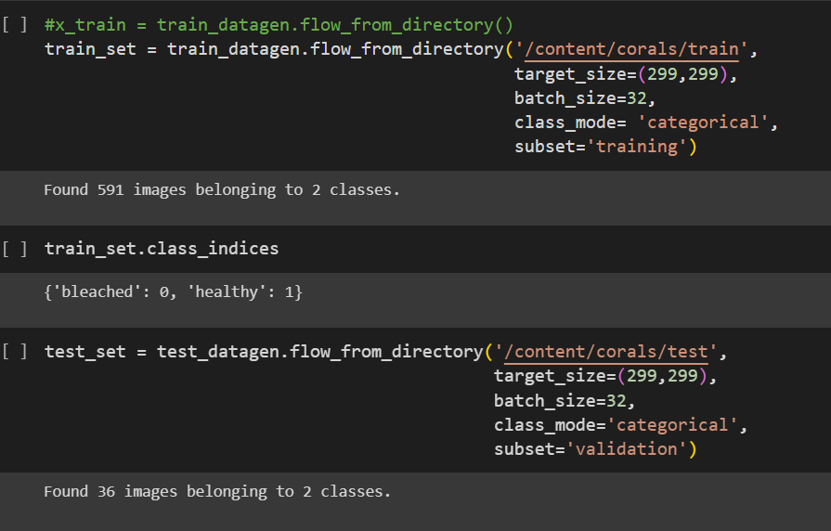

ImageDataGenerator is a class in Keras that provides a suite of techniques for scaling pixel values in your image dataset prior to modeling. It is used for implementing image augmentation, which can generate augmented images dynamically during the training of the model, making the overall mode more robust and accurate. The class wraps your image dataset and returns images in batches to the algorithm during training, validation, or evaluation and applies the scaling operations just-in-time

www.smartbridge.com

# Milestone 3: Model Building

VGG16 is a convolution neural network (CNN) model supporting layers.

The VGG Net architecture incorporates the most important convolution neural network features. The convolutional filters of VGG use the smallest possible receptive field of 3×3 . The VGG16 model can achieve a test accuracy of 84% .

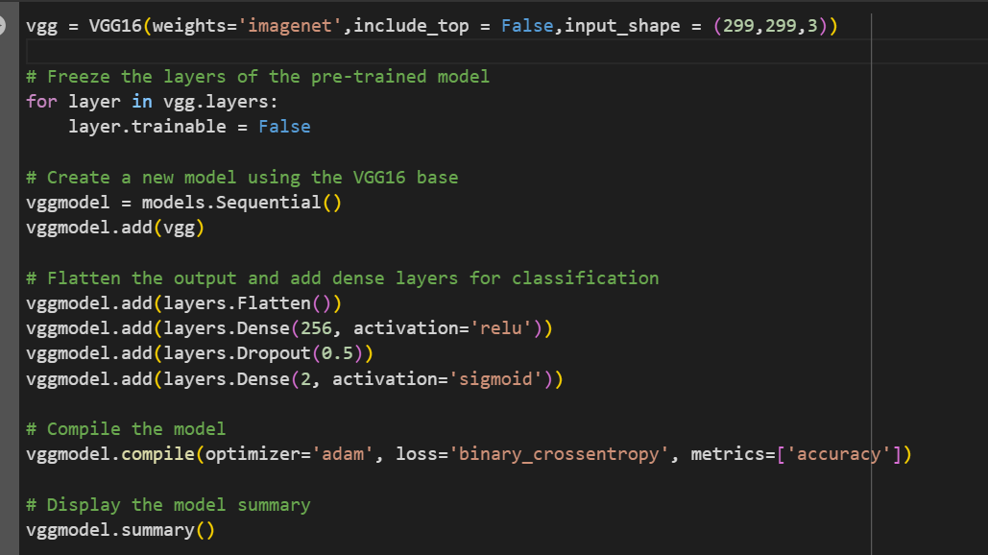

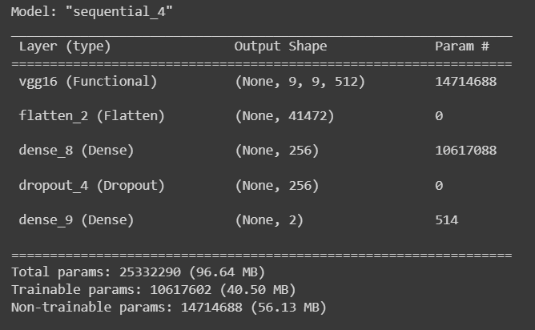

www.smartbridge.com

**Activity 3: Configure the Learning Process**

The compilation is the final step in creating a model. Once the compilation is done, we can move on to the training phase. The loss function is used to find errors or deviations in the learning process.

Keras requires a loss function during the model compilation process.

Optimization is an important process that optimizes the input weights by comparing the prediction and the loss function. Here we are using adam optimizer Metrics are used to evaluate the performance of your model. It is similar to the loss function, but not used in the training process.



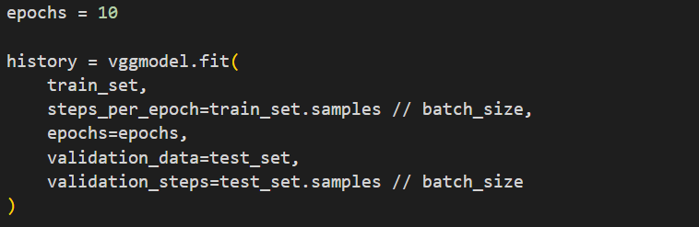

**Activity 4: Train the model**

Now, let us train our model with our image dataset. The model is trained for 10 epochs and after every epoch, the current model state is saved if the model has the least loss encountered till that time. We can see that the training loss decreases in almost every epoch and probably there is further scope to improve the model. **fit_generator** functions used to train a deep learning neural network

**Arguments:**

* steps_per_epoch: it specifies the total number of steps taken from the generator as soon as one epoch is finished and the next epoch has started. We can calculate the value of steps_per_epoch as the total number of samples in your dataset divided by the batch size.
* Epochs: an integer and number of epochs we want to train our model for.

www.smartbridge.com

* validation_data can be either:
  + an inputs and targets list
  + a generator
  + an inputs, targets, and sample_weights list which can be used to evaluate the loss and metrics for any model after any epoch has ended.
* validation_steps: only if the validation_data is a generator then only this argument can be used. It specifies the total number of steps taken from the generator before it is stopped at every epoch and its value is calculated as the total number of validation data points in your dataset divided by the validation batch size.

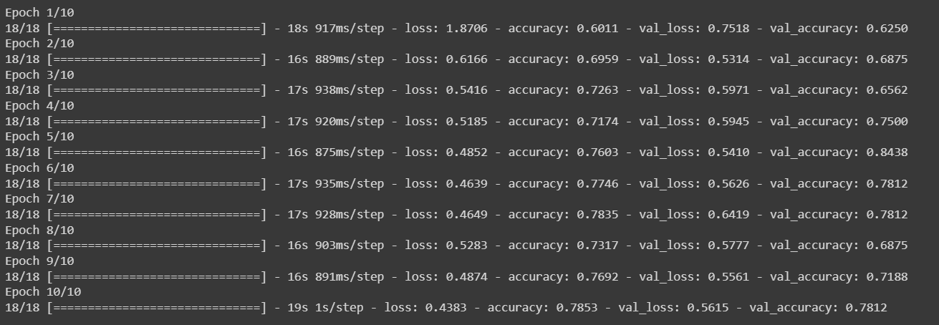

[www.smartbridge.com](http://www.smartbridge.com/)

**Milestone 4: Save the Model**

The model is saved with .h5 extension as follows

An H5 file is a data file saved in the Hierarchical Data Format (HDF). It contains multidimensional arrays of scientific data.

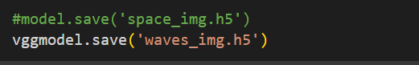

**Load and test the model.**

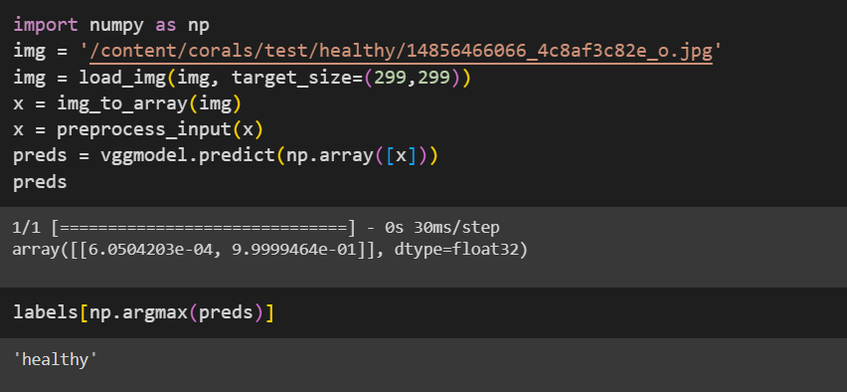

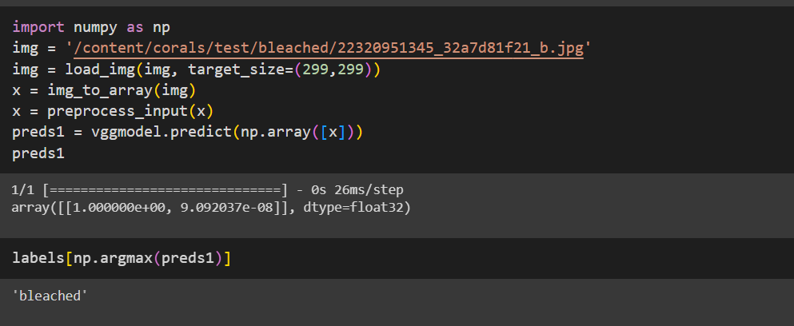

[www.smartbridge.com](http://www.smartbridge.com)

# Milestone 5: Application Building

Now that we have trained our model, let us build our flask application which will be

running in our local browser with a user interface.

In the flask application, the input parameters are taken from the HTML page These factors are then given to the model to know to predict the type of Garbage and showcased on the HTMLpage to notify the user. Whenever the user interacts with the UI and selects the “Image” button, the next page is opened where the user chooses the image and predicts the output.

Activity 1 : Create HTML Pages o We use HTML to create the front end part of the web page.

* Here, we have created 3 HTML pages- index.html, inner.html, and output.html
* index.html displays the home page.
* inner.html displays to upload image.
* outer.html give the result

For more information regarding HTML https://www.w3schools.com/html/

o We also use JavaScript-main.js and CSS-main.css to enhance our functionality and view of HTML pages.

www.smartbridge.com

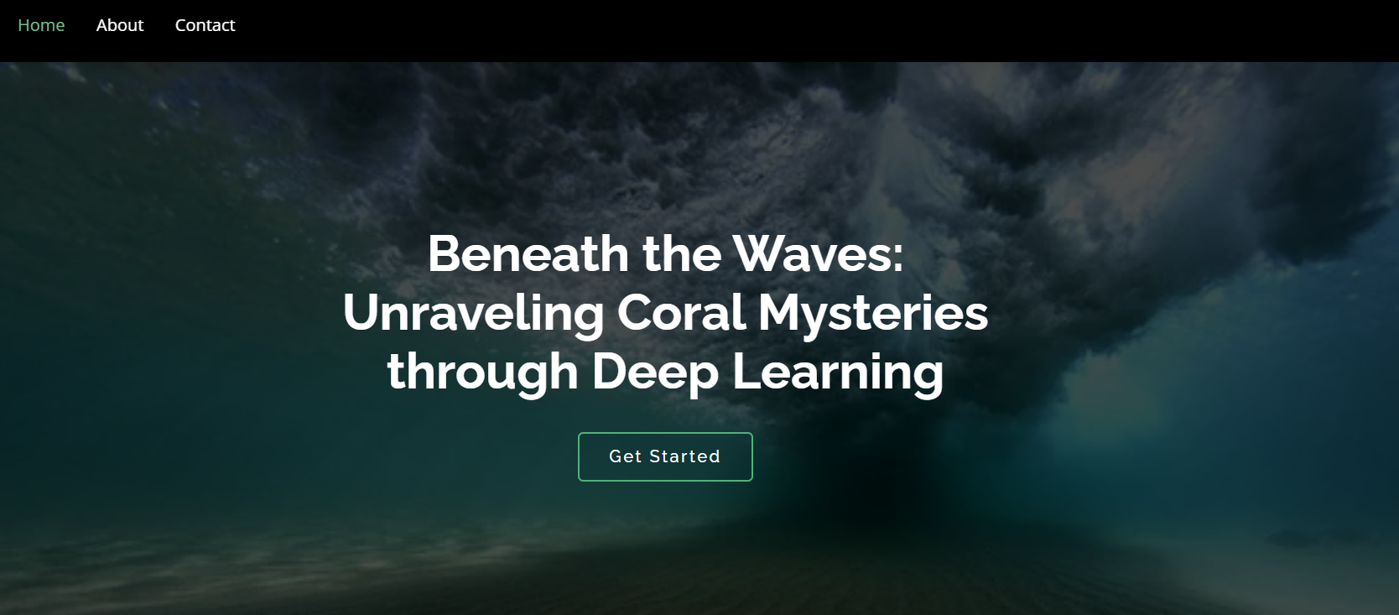

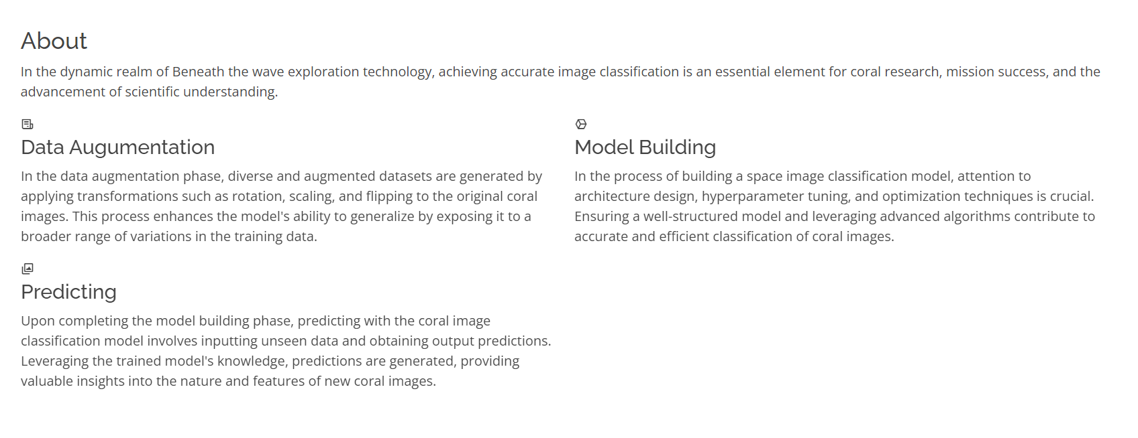

www.smartbridge.com

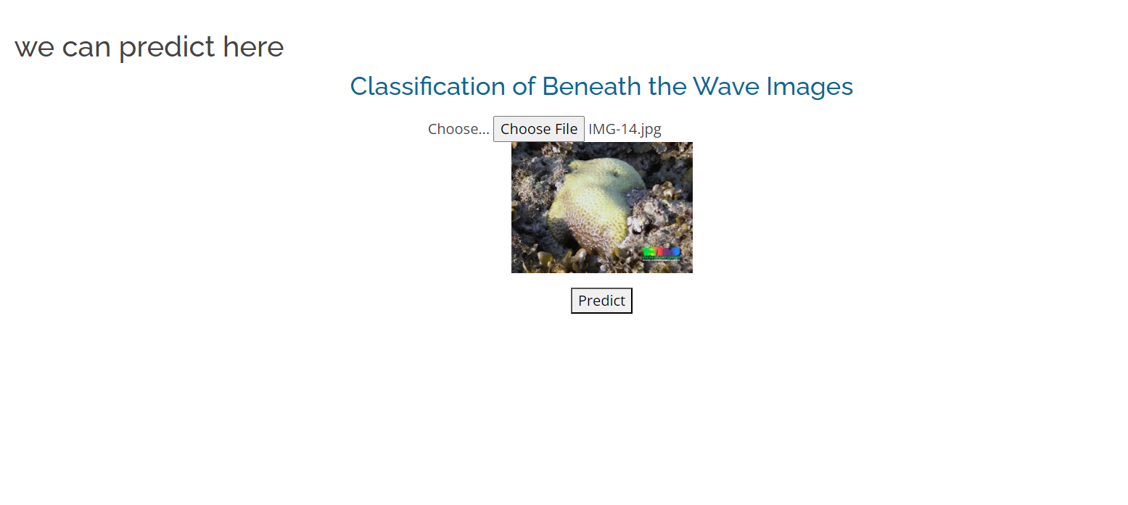

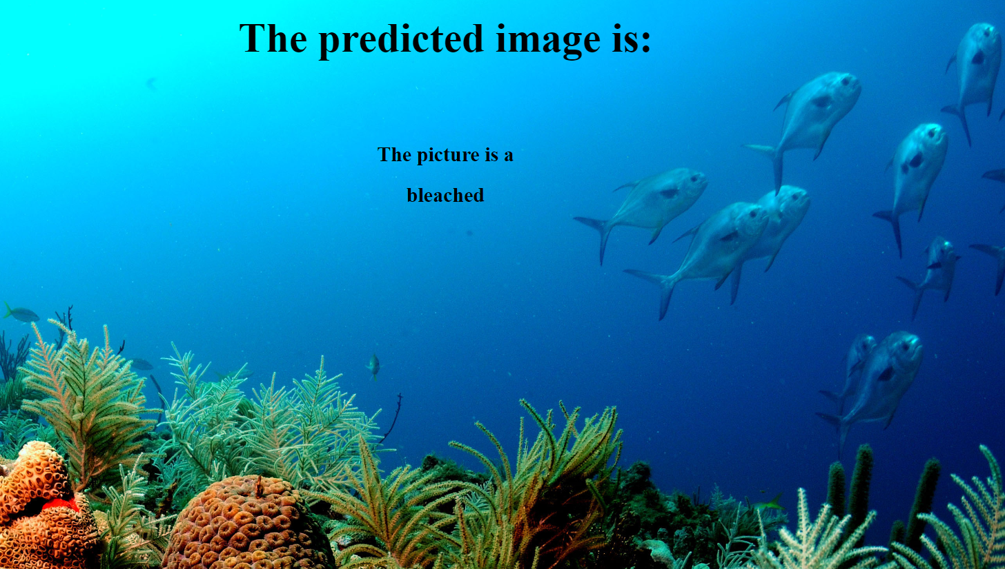

www.smartbridge.com

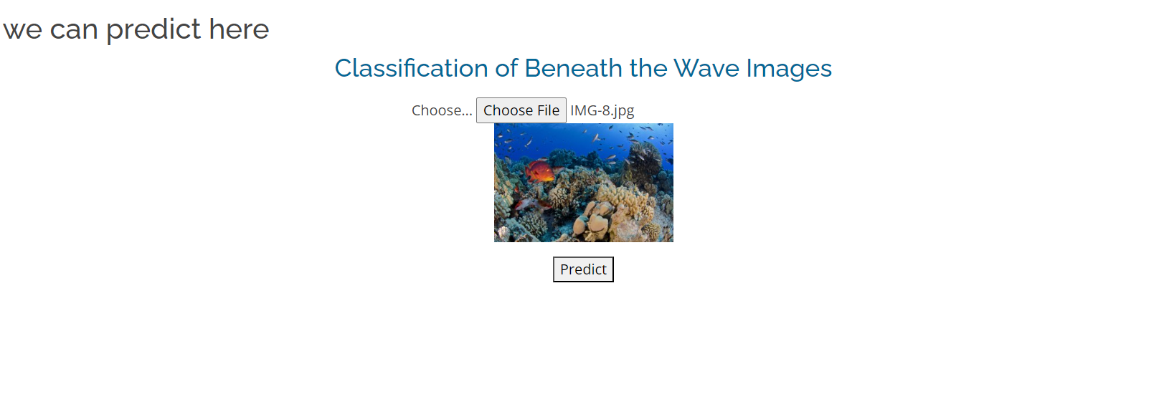

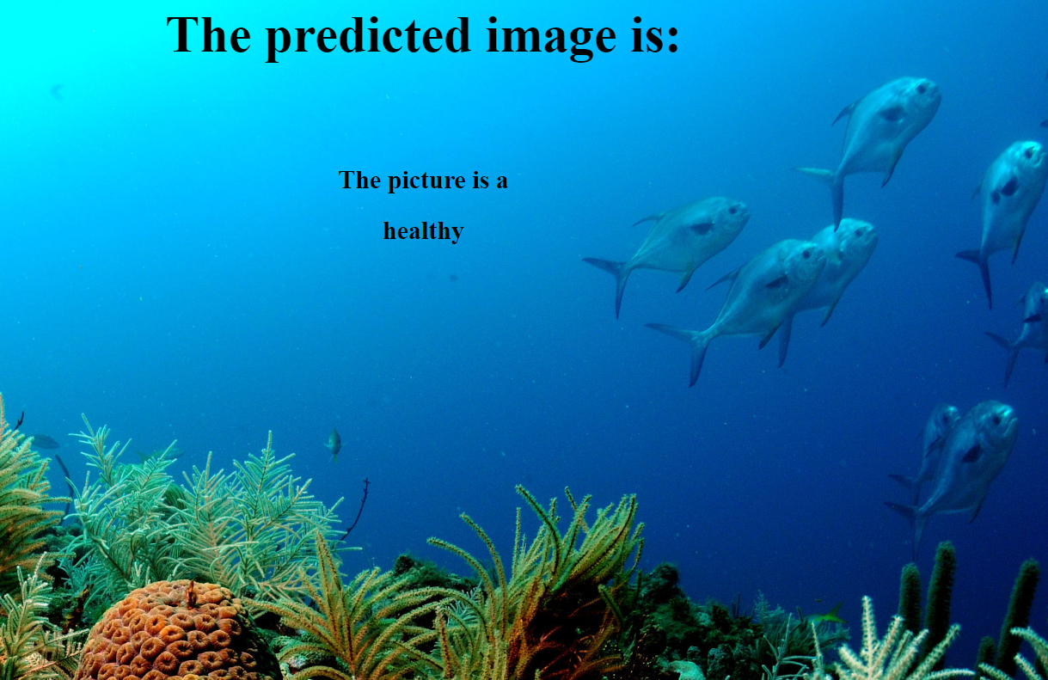

This is a Python script for a Flask web application that loads a pre-trained deep learning model for image classification and makes predictions on images uploaded by the user. The app has several routes, such as the home page ('/'), the inner page ('/inner.html'), and the output page('/output.html'). The main prediction functionality is implemented in the '/result' route, where the uploaded image is loaded, pre -processed, and passed through the model for prediction. The predicted result is then displayed on the prediction page. The app can be run by executing the script, and it will start a local server accessible through a web browser.

www.smartbridge.com

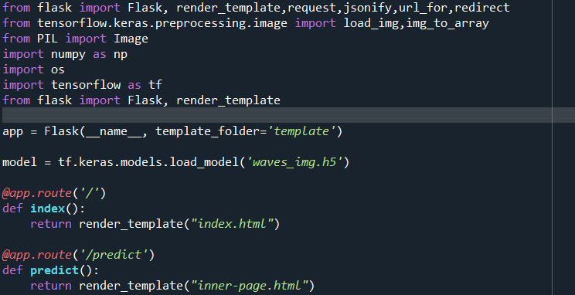

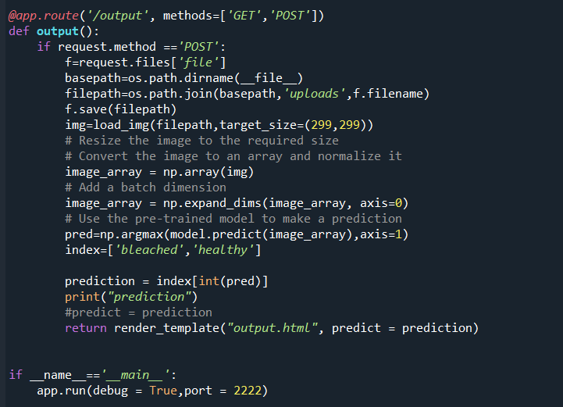

To run this Flask application, simply navigate to the project directory in the terminal and run the command "python app.py". This will start the Flask server, and you can access the web application by visiting the local host address in your web browser. Once you upload an image and submit the form, the application will use the trained model to predict the species of the plant in the image and display the result on the page.

www.smartbridge.com